St. Peter’s Episcopal Church
30 Church Street
Hebron, CT

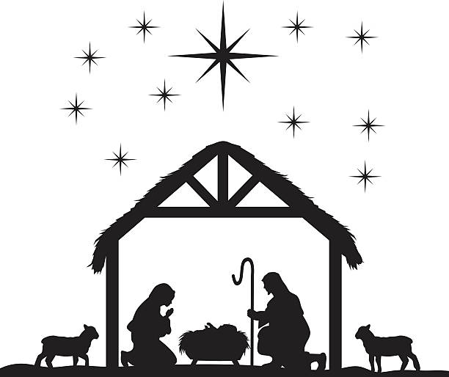

A Festival of Lessons and Carols
DECEMBER 31, 2023
A Festival of Lessons and Carols
January 1, 2022
10:00 a.m. Holy Eucharist

A Festival of Lessons and Carols
Prelude

Hymn at the Procession #83 “O Come, all ye faithful “(vv.1-3, 6)

Dear People of God,
In Christmas Season, let it be our duty and delight to hear once more the message of the Angels, to go to Bethlehem and see the Son of God lying in a manger. Let us hear and heed in Holy Scripture the story of God’s loving purpose from the time of our rebellion against him until the glorious redemption brought to us by his holy child, Jesus, and let us make this place glad with our carols of praise.

But first, let us pray for the needs of the whole world, for peace and justice on earth, for the unity and mission of the Church for which he died, and especially for his Church in our country and in this village. And, because he particularly loves them, let us remember in his name the poor and helpless, the cold, the hungry and the oppressed, the sick and those who mourn, the lonely and the unloved, the aged and little children, as well as all who do not know and love the Lord Jesus Christ.

Finally, let us remember before God his pure and lowly Mother, and that whole multitude which no one can number, whose hope was in the Word made flesh, and with whom, in Jesus, we are one forevermore. And now, to sum up these petitions, let us pray in the words which Christ himself taught us, saying:

The Lord’s Prayer
Our Father, Who art in Heaven, hallowed be thy Name.
Thy Kingdom come, Thy will be done,
On earth as it is in Heaven.
Give us this day our daily bread; and forgive us our trespasses,
As we forgive those who trespass against us.
And lead us not into temptation,
But deliver us from evil.
For thine is the Kingdom, the power and the glory,
now and forever. Amen.

Invitatory Hymn #60 “Creator of the Stars of Night”

Lesson 1: Genesis 3:1-23

~ Adam and Eve rebel against God

and are cast out of the Garden of Eden ~

Now the serpent was more crafty than any other wild animal that the LORD God had made. He said to the woman, "Did God say, 'You shall not eat from any tree in the garden'?" The woman said to the serpent, "We may eat of the fruit of the trees in the garden; but God said, 'You shall not eat of the fruit of the tree that is in the middle of the garden, nor shall you touch it, or you shall die.'" But the serpent said to the woman, "You will not die; for God knows that when you eat of it your eyes will be opened, and you will be like God, knowing good and evil." So when the woman saw that the tree was good for food, and that it was a delight to the eyes, and that the tree was to be desired to make

one wise, she took of its fruit and ate; and she also gave some to her husband, who was with her, and he ate. Then the eyes of both were opened, and they knew that they were naked; and they sewed fig leaves together and made loincloths for themselves. They heard the sound of the LORD God walking in the garden at the time of the evening breeze, and the man and his wife hid themselves from the presence of the LORD God among the trees of the garden.

But the LORD God called to the man, and said to him, "Where are you?" He said, "I heard the sound of you in the garden, and I was afraid, because I was naked; and I hid myself." He said, "Who told you that you were naked? Have you eaten from the tree of which I commanded you not to eat?" The man said, "The woman whom you gave to be with me, she gave me fruit from the tree, and I ate." Then the LORD God said to the woman, "What is this that you have done?" The woman said, "The serpent tricked me, and I ate." The LORD God said to the serpent, "Because you have done this, cursed are you among all animals and among all wild creatures; upon your belly you shall go, and dust you shall eat all the days of your life. I will put enmity between you and the woman, and between your offspring and hers; he will strike your head, and you will strike his heel." To the woman he said, "I will greatly increase your pangs in childbearing; in pain you shall bring forth children, yet your desire shall be for your husband, and he shall rule over you." And to the man he said, "Because you have listened to the voice of your wife, and have eaten of the tree

about which I commanded you, 'You shall not eat of it,' cursed is the ground because of you; in toil you shall eat of it all the days of your life; thorns and thistles it shall bring forth for you; and you shall eat the plants of the field. By the sweat of your face you shall eat bread until you return to the ground, for out of it you were taken; you are dust, and to dust you shall return." The man named his wife Eve, because she was the mother of all living. And the LORD God made garments of skins for the man and for his wife, and clothed them. Then the LORD God said, "See, the man has become like one of us, knowing good and evil; and now, he might reach out his hand and take also from the tree of life, and eat, and live forever"-- therefore the LORD God sent him forth from the garden of Eden, to till the ground from which he was taken.

Hymn: #65 "Comfort, comfort ye my people"

Lesson 2: Isaiah 40:1-11

~ God’s People Are Comforted ~
Comfort, O comfort my people, says your God. Speak tenderly to Jerusalem, and cry to her that she has served her term, that her penalty is paid, that she has received from the Lord’s hand double for all her sins.
A voice cries out: ‘In the wilderness prepare the way of the Lord, make straight in the desert a highway for our God. Every valley shall be lifted up, and every mountain and hill be made low; the uneven ground shall become level, and the rough places a plain.

Then the glory of the Lord shall be revealed, and all people shall see it together, for the mouth of flower fades when the breath of the Lord blows upon it; surely the people are grass. The grass withers, the flower fades; but the word of our God will stand for ever. Get you up to a high mountain, O Zion, herald of good tidings; lift up your voice with strength, O Jerusalem, herald of good tidings, lift it up, do not fear; say to the cities of Judah, ‘Here is your God!’ See, the Lord God comes with might, and his arm rules for him; his reward is with him, and his recompense before him. He will feed his flock like a shepherd; he will gather the lambs in his arms, and carry them in his bosom, and gently lead the mother sheep.

Hymn #265 “The Angel Gabriel from Heaven Came”

Lesson 3: Luke 1:26-38

~ The Birth of Jesus Foretold ~
In the sixth month the angel Gabriel was sent by God to a town in Galilee called Nazareth, to a virgin engaged to a man whose name was Joseph, of the house of David. The virgin’s name was Mary. And he came to her and said, ‘Greetings, favored one! The Lord is with you.’ But she was much perplexed by his words and pondered what sort of greeting this might be.

The angel said to her, ‘Do not be afraid, Mary, for you have found favor with God. And now, you will conceive in your womb and bear a son, and you will name him Jesus. He will be great, and will

be called the Son of the Most High, and the Lord God will give to him the throne of his ancestor David. He will reign over the house of Jacob for ever, and of his kingdom there will be no end.’ Mary said to the angel, ‘How can this be, since I am a virgin?’ The angel said to her, ‘The Holy Spirit will come upon you, and the power of the Most High will overshadow you; therefore the child to be born will be holy; he will be called Son of God. And now, your relative Elizabeth in her old age has also conceived a son; and this is the sixth month for her who was said to be barren. For nothing will be impossible with God.’ Then Mary said, ‘Here am I, the servant of the Lord; let it be with me according to your word.’ Then the angel departed from her.

Hymn #81: “Lo, how a rose e’er blooming”

Lesson Four: Luke 1:39-56

~ Mary Visits Elizabeth ~
In those days Mary set out and went with haste to a Judean town in the hill country, where she entered the house of Zechariah and greeted Elizabeth. When Elizabeth heard Mary’s greeting, the child leapt in her womb. And Elizabeth was filled with the Holy Spirit and exclaimed with a loud cry, ‘Blessed are you among women, and blessed is the fruit of your womb. And why has this happened to me, that the mother of my Lord comes to me? For as soon as I heard the sound of your greeting, the child in my womb leapt for joy. And blessed is she who believed that there would be a fulfilment of what was spoken to her by the Lord.’

Mary’s Song of Praise
And Mary said, ‘My soul magnifies the Lord,
and my spirit rejoices in God my Savior,
for he has looked with favor on the lowliness of his servant.
Surely, from now on all generations will call me blessed;
for the Mighty One has done great things for me,
and holy is his name.
His mercy is for those who fear him
from generation to generation.
He has shown strength with his arm;
he has scattered the proud in the thoughts of their hearts.
He has brought down the powerful from their thrones,
and lifted up the lowly;
he has filled the hungry with good things,
and sent the rich away empty.
He has helped his servant Israel,
in remembrance of his mercy,
according to the promise he made to our ancestors,
to Abraham and to his descendants for ever.’

And Mary remained with her for about three months and then returned to her home.

Hymn #102 "Once in Royal David's City" (v. 1, 2)

Lesson 5: Luke 2:1-20
~Jesus is born at Bethlehem
and is worshipped by angels and shepherds~
In those days a decree went out from Emperor Augustus that all the world should be registered. This was the first registration and was taken while Quirinius was governor of Syria. All went to their own towns to be registered. Joseph also went from the town of Nazareth in Galilee to Judea, to the city of David called Bethlehem, because he was descended from the house and family of David. He went to be registered with Mary, to whom he was engaged and who was expecting a child. While they were there, the time came for her to deliver her child. And she gave birth to her firstborn son and wrapped him in bands of cloth, and laid him in a manger, because there was no place for them in the inn.

In that region there were shepherds living in the fields, keeping watch over their flock by night. Then an angel of the Lord stood before them, and the glory of the Lord shone around them, and they were terrified. But the angel said to them, ‘Do not be afraid; for see—I am bringing you good news of great joy for all the people: to you is born this day in the city of David a Savior, who is the Messiah, the Lord. This will be a sign for you: you will find a child wrapped in bands of cloth and lying in a manger.’ And suddenly there was with the angel a multitude of the heavenly host, praising God and saying, ‘Glory to God in the highest heaven, and on earth peace among those whom he favors!’

When the angels had left them and gone into heaven, the shepherds said to one another, ‘Let us go now to Bethlehem and see this thing that has taken place, which the Lord has made known to us.’ So they went with haste and found Mary and Joseph, and the child lying in the manger. When they saw this, they made known what had been told them about this child; and all who heard it were amazed at what the shepherds told them. But Mary treasured all these words and pondered them in her heart. The shepherds returned, glorifying and praising God for all they had heard and seen, as it had been told them.

Hymn #82 "Of the Fathers Love begotten"

Lesson 6: Luke 2:21-39
~ Jesus receives his name
and is presented to Simeon in the Temple ~
After eight days had passed, it was time to circumcise the child; and he was called Jesus, the name given by the angel before he was conceived in the womb.

When the time came for their purification according to the law of Moses, they brought him up to Jerusalem to present him to the Lord (as it is written in the law of the Lord, ‘Every firstborn male shall be designated as holy to the Lord’), and they offered a sacrifice according to what is stated in the law of the Lord, ‘a pair of turtle-doves or two young pigeons.’

Now there was a man in Jerusalem whose name was Simeon; this man was righteous and devout, looking forward to the consolation of Israel, and the Holy Spirit rested on him. It had been revealed to him by the Holy Spirit that he would not see death before he had seen the Lord’s Messiah. Guided by the Spirit, Simeon came into the temple; and when the parents brought in the child Jesus, to do for him what was customary under the law, Simeon took him in his arms and praised God, saying,
‘Master, now you are dismissing your servant in peace,
according to your word; for my eyes have seen your
salvation, which you have prepared
in the presence of all peoples,
a light for revelation to the Gentile
and for glory to your people Israel.’
And the child’s father and mother were amazed at what was being said about him. Then Simeon blessed them and said to his mother Mary, ‘This child is destined for the falling and the rising of many in Israel, and to be a sign that will be opposed so that the inner thoughts of many will be revealed—and a sword will pierce your own soul too.’

There was also a prophet, Anna the daughter of Phanuel, of the tribe of Asher. She was of a great age, having lived with her husband for seven years after her marriage, then as a widow to the age of eighty-four. She never left the temple but worshipped there with fasting and prayer night and day. At that moment she

came, and began to praise God and to speak about the child to all who were looking for the redemption of Jerusalem.

When they had finished everything required by the law of the Lord, they returned to Galilee, to their own town of Nazareth.

Hymn #107 "Good Christian Friends Rejoice"

Lesson 7: John 1:1-18
~ The Word Became Flesh ~
In the beginning was the Word, and the Word was with God, and the Word was God. He was in the beginning with God. All things came into being through him, and without him not one thing came into being. What has come into being in him was life, and the life was the light of all people. The light shines in the darkness, and the darkness did not overcome it.

There was a man sent from God, whose name was John. He came as a witness to testify to the light, so that all might believe through him. He himself was not the light, but he came to testify to the light. The true light, which enlightens everyone, was coming into the world.

He was in the world, and the world came into being through him; yet the world did not know him. He came to what was his own, and his own people did not accept him. But to all who received him, who believed in his name, he gave power to become children

of God, who were born, not of blood or of the will of the flesh or of the will of man, but of God.

And the Word became flesh and lived among us, and we have seen his glory, the glory as of a father’s only son, full of grace and truth. (John testified to him and cried out, ‘This was he of whom I said, “He who comes after me ranks ahead of me because he was before me.” ’) From his fullness we have all received, grace upon grace. The law indeed was given through Moses; grace and truth came through Jesus Christ. No one has ever seen God. It is God the only Son, who is close to the Father’s heart, who has made him known.

Hymn #82 “Of the Father’s Love Begotten”

The Apostles’ Creed (The Officiant leads the people in saying the Creed, all standing)
I believe in God, the Father almighty,
creator of heaven and earth.
I believe in Jesus Christ, his only Son, our Lord.
He was conceived by the power of the Holy Spirit
and born of the Virgin Mary.
He suffered under Pontius Pilate, was crucified,
died, and was buried.
He descended to the dead.
On the third day he rose again.
He ascended into heaven, and is seated
at the right hand of the Father.
He will come again to judge the living and the dead.
I believe in the Holy Spirit, the holy catholic Church,
the communion of saints,
the forgiveness of sins,
the resurrection of the body,
and the life everlasting. Amen.

Prayers of the People for Christmas
Presider: As we join the angels and celebrate with joy the birth of the Son of God, let us offer prayers to God who gives new birth to sons and daughters in every place.

Leader: By the birth of the timeless Son of God in the womb of the Virgin Mary.
Silence
Leader: Let us pray to the Lord
People: Glory and praise to you, O living God.

Leader: For Jeff and Laura our bishops, Ron our priest, Donna & Marge our deacons and all the presbyters, priests & deacons, and all who minister in Christ, and for all the holy people of God.
Silence
Leader: Let us pray to the Lord
People: Glory and praise to you, O living God.

Leader: For the leaders of the nations and all in authority, and for peace and justice especially in the Holy Land, Ukraine, Sudan and Yemen.
Silence
Leader: Let us pray to the Lord
People: Glory and praise to you, O living God.

Leader: For travelers, for the sick and the suffering, for the hungry and the oppressed, for those in prison, and for the dying and the dead. Remembering especially those for whom memorials have been given and are listed in our worship bulletin this Christmas season.
Silence
Leader: Let us pray to the Lord
People: Glory and praise to you, O living God.

Leader: For our deliverance from all affliction, strife, and need.
Silence
Leader: Let us pray to the Lord
People: Glory and praise to you, O living God.

Leader: Remembering our most glorious and blessed Virgin Mary, Peter, and all the saints, let us offer ourselves and one another to the living God through Christ.
Silence

Leader: Let us pray to the Lord
People: To you, O Lord.

Presider: Source of light and gladness, accept the prayers we offer on this joyful feast. May we grow in Jesus Christ who unites our lives to yours and who is Lord for all eternity; through Jesus Christ our Lord.
People: Amen.
The Collect for the Day: Almighty God, you have poured upon us the new light of your incarnate Word: Grant that this light, enkindled in our hearts, may shine forth in our lives; through Jesus Christ our Lord, who lives and reigns with you, in the unity of the Holy Spirit, one God, now and for ever. Amen.

A Collect for Sundays: O God, you make us glad with the weekly remembrance of the glorious resurrection of your Son our Lord: Give us this day such blessing through our worship of you, that the week to come may be spent in your favor; through Jesus Christ our Lord. Amen.

A Collect for Mission: Almighty and everlasting God, by whose Spirit the whole body of your faithful people is governed and sanctified: Receive our supplications and prayers which we offer before you for all members of your holy Church, that in their vocation and ministry they may truly and devoutly serve you; through our Lord and Savior Jesus Christ. Amen.

A Collect for Peace: O God, the author of peace and lover of concord, to know you is eternal life and to serve you is perfect freedom: Defend us, your humble servants, in all assaults of our enemies; that we, surely trusting in your defense, may not fear the power of any adversaries; through the might of Jesus Christ
our Lord. Amen.

The Peace (All stand)
Officiant: The peace of the Lord be always with you.
People: And also with you.
Announcements

After the announcements, the Officiant introduces the offertory with the sentence:

Officiant: Walk in love as Christ loved us and by whose death on the cross showed us the way to eternal life.
Offertory Hymn: #110 “The snow lay on the ground”

The General Thanksgiving (all standing) BCP, page 101
Officiant: In thanksgiving for the many blessings of our lives,
let us pray.

All: Almighty God, Father of all mercies, we your unworthy servants give you humble thanks for all your goodness and loving-kindness to us and to all whom you have made. We bless you for our creation, preservation, and all the blessings of this life; but above all for your immeasurable love in the redemption of the world by our Lord Jesus Christ; for the means of grace, and for the hope of glory. And, we pray, give us such an awareness of your mercies, that with truly thankful hearts we may show forth your praise, not only with our lips, but in our lives, by giving up ourselves to your service, and by walking before you in holiness and righteousness all our days; through Jesus Christ our Lord, to whom, with you and the Holy Spirit, be honor and glory throughout all ages. Amen.

The Officiant concludes the service with the following prayer.

A Prayer of St. Chrysostom BCP page 102
Almighty God, you have given us grace at this time with one accord to make our common supplication to you; and you have promised through your well-beloved Son that when two or three are gathered together in his Name you will be in the midst of them: Fulfill now, O Lord, our desires and petitions as may be best for us; granting us in this world knowledge of your truth, and in the age to come life everlasting. Amen.

Officiant: Let us bless the Lord
People: Thanks be to God.

The Dismissal
People: Thanks be to God. Alleluia, Alleluia!

Closing Hymn: #100 “Joy to the World”

Postlude

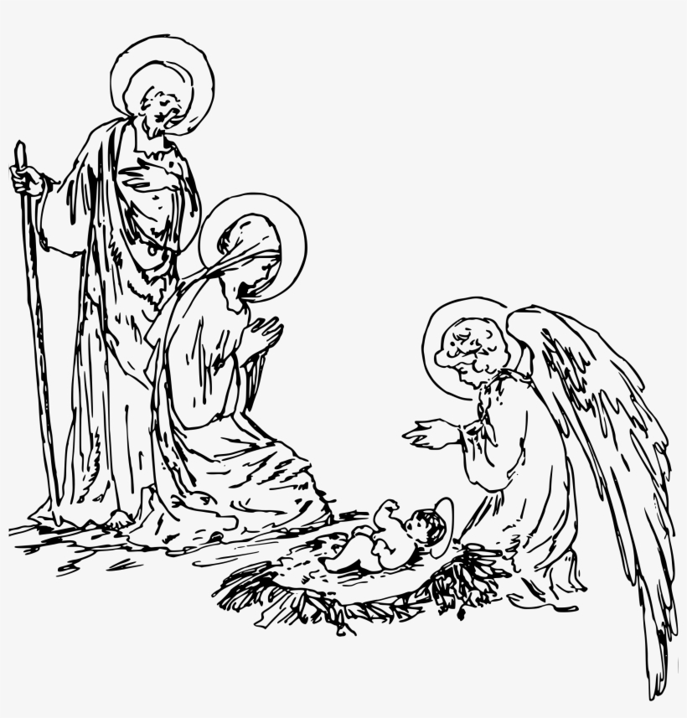

Christmas Memorial Giving
Given by |  |  | In Loving Memory of
Len & Judi |  | Babin | Charles & Priscilla Davis, Deborah Davis  Leonard & Anna Babin
Judith |  | Banks | John Banks
Trisha Beatty |  | & George Dagon | Petra & Jack Beatty, Mary Ellen Dagon
Carolyn |  | Bouchard | Frank Sighinolfi
Claire |  | Bracaglia | Henry Lindert, Henry Jones, Helen Wason
Cynthia |  | Brinkman | John G. Brinkman, Jr.
Clyde and Georgette |  | Conrad | All our military away from home at the holidays
Marge |  | Dill | Michael Dill, Joan Conley
Henry & Joyce |  | Dombrowski | Henry & Elizabeth Dombrowski, John and Angie Banulski, Judy, Dave & David Martin
Marcia & Chuck |  | Eaton | Ethel, Harrison, Harry & John Eaton, Barbara, Georgia, George & Lee Potterton, Jack & Pam
The |  | Eells Family | Clarence and Terry Michaud, and Bonnie Eells
Stephen & Victoria |  | Fisk | Aunt Yolanda Bettancourt, in memorandum for her life (RIP Nov 13 2023)
 |  |  | Marcos Antonio Vidal-Mardones (Victoria's Father), in Memorandum for his life
The |  | Forrest Family | Walter Forrest, George W. Clark
Cathy & Chris |  | Gerke | Ralph & Elizabeth Gerke,  Elizabeth & John McCashland
Maryann |  | Hickelton | My St. Peter's Family
Mark & Laurel |  | Houle | Dorothy Proctor Houle, Carmela Maria Terlizzi
Gayle Porter |  | Kataja | Peter C. Kataja, Merle N. & E. Earl Porter, Kyle P. Buttice
Kathy |  | Kniep | Jeanne and Robert Wessman, Paul LeBreton; Evangeline and Blanche Kniep
Judy |  | Knowlton |  | Douglas A. Knowlton, Thomas Knowlton
Ron |  | Kolanowski &  Art Engler |  | Mel & Helen Hiltabel, Art & Helen Kolanowski, Lori & Julie Kolanowski, Germain & George Kolanowski, Joseph and Anna Brandis, Thomas and Pearl Walker
Curt & Ellen |  | Kraemer |  | Joann Vechinsky
Mary |  | Latour |  | Alice Hagenow, Richard J. Hagenow, Richard T. Hagenow
John |  | Loge |  | Frances Jean Loge, Beverly Jane Sandefur,  Judith Marion Gray, Stuart Edgar Power
Lynda |  | Majewski |  | Paul Louis Arruda
Bob |  | ManWarren |  | Lavern and Nita Manwarren
John & Sandy |  | Marshall |  | Their parents
The |  | Mondrach Family |  | for our beloved family members who have gone before us.
Nelson and Marianne |  | Moore |  | Kenneth Moore, Glenn Moore, Maitland Moore, Martha Moore, Herbert G. Richter, Linda Richter
The |  | Myers Family |  | P. Hamilton & Ruth Myers; Tom and Martha Bombaci; Bob & Bev Winter
Christine |  | Nosal |  | Ron Tredor
The |  | O'Shea Family |  | Jean & Ray Baldwin, Carbery & Genevieve O'Shea, Genevieve Alexander, Margo Fletcher, Christine Morrison, Sean O'Shea, Juanita & Jack Alden
The |  | Osmond Family |  | Cleo & Doris Wandling, John B. & Mildred Osmond, John C. Osmond
John & Susan |  | Ostrout |  | Elmer H. Ostrout, Sr., Dorothy R. Ostrout,  William Murray, Shirley Murray, Edward Murray
Barbara |  | Parkyn |  | Our Family loved ones; Marge Caton
Steve |  | Platz |  | Judy, Ed & Linda Platz, Henry & Evelyn Dickinson
Chris & Chad |  | Raasumaa-Boots |  | Nana, Bachi & Dziadzi
 | Fran & Lino | Rodegher |  | Sandra Guglielmi, Lino, Livio & Gianfranco Rodegher
 | Amy | Stone | In loving memory of friends and family members
 | Lianie | Unterzuber | Bob Gorcenski, Dee Urban, Maidey
 |  |  | Mary Jo Keenan, John Romero
 |  |  | Debbie Bell, Anastasios Philippou
 | John | Viklinetz | Helen Joy Viklinetz
 | Stephanie | Wheeler | Russell H. Wheeler, Jr., Joyce M. Leombruno
 | Debbie | Wilson | John & Anita Wilson
 | Stephen | Wells | Carol A. Wells
St. Peter’s Family remembers with fondness those members who have died this year:

Lou Amara
John Banks
Sam Downey
John Eaton
Les Hamilton

Irene Jones
Rick Marks, Sr.
Gail Merritt
John Osmond
Bob Winter




Gifts Given in Honor
 | Given by |  | In honor of
 | Cindy | Brinkman | Her grandchildren.
 | Stephen & Victoria | Fisk | Family and friends: In Thanksgiving/Gratefulness for their lives
 | The | Forrest Family | Ryan Clark and service members
 | Steve | Konopka | Jesus, wishing him a happy birthday
 | Cathie & Ray | Litwin | In thanksgiving for all our family and friends
 | Antonella | Woerle | In support of St. Peter’s

