St. Peter’s Episcopal Church

The Eve of the Nativity of Our Lord

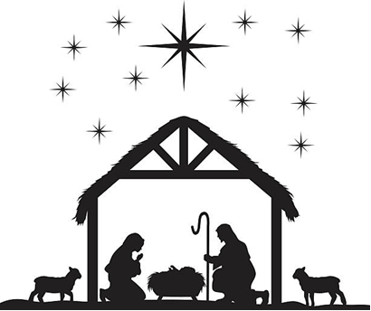

December 24, 2023
Holy Eucharist
4:30 p.m.

Holy Eucharist
Preludes:

Welcome
Celebrant: The word became flesh and dwelt among us:
People: And we beheld his glory.
Celebrant: Almighty and everliving God, you have given us a new revelation of your loving providence in the coming of your Son Jesus Christ to be born of the Virgin Mary: Grant that as he shared our mortality, so we may share his eternity in the glory of your kingdom; where he lives and reigns for ever and ever. Amen.

Opening Hymn: #83 “O Come All Ye Faithful” (vs. 1, 2, 3, 6)

Celebrant: Alleluia! The people who walked in darkness have seen a great light!
People: Glory to God in the highest, and peace to God’s people on earth.

Gloria: #96 “Angels we have heard on high” (vs. 1 & 3)

Celebrant: The Lord be with you.
People: And also with you.
Celebrant: Let us pray.
Collect of the Day: O God, you make us glad by the yearly festival of the birth of your only Son Jesus Christ: Grant that we, who joyfully receive him as our Redeemer, may with sure confidence behold him when he comes to be our Judge; who lives and reigns with you and the
Holy Spirit, one God, now and for ever. Amen.

First Reading: Isaiah 9:2-7
The people who walked in darkness have seen a great light; those who lived in a land of deep darkness--on them light has shined. You have multiplied the nation, you have increased its joy; they rejoice before you as with joy at the harvest, as people exult when dividing plunder. For the yoke of their burden, and the bar across their shoulders, the rod of their oppressor, you have broken as on the day of Midian. For all the boots of the tramping warriors and all the garments rolled in blood shall be burned as fuel for the fire. For a child has been born for us, a son given to us; authority rests upon his shoulders; and he is named Wonderful Counselor, Mighty God, Everlasting Father, Prince of Peace. His authority shall grow continually, and there shall be endless peace for the throne of David and his kingdom. He will establish and uphold it with justice and with righteousness from this time onward and forevermore. The zeal of the Lord of hosts will do this.
Reader: The Word of the Lord. People: Thanks be to God.

The Psalm (prayed in unison) Psalm 97
1 The Lord is King; let the earth rejoice; *
let the multitude of the isles be glad.
2 Clouds and darkness are round about him, *
righteousness and justice are the foundations of his throne.
3 A fire goes before him *
and burns up his enemies on every side.
4 His lightnings light up the world; *
the earth sees it and is afraid.
5 The mountains melt like wax at the presence of the Lord, *
at the presence of the Lord of the whole earth.
6 The heavens declare his righteousness, *
and all the peoples see his glory.
7 Confounded be all who worship carved images
and delight in false gods! *
Bow down before him, all you gods.
8 Zion hears and is glad, and the cities of Judah rejoice, *
because of your judgments, O Lord.
9 For you are the Lord, most high over all the earth; *
you are exalted far above all gods.
10 The Lord loves those who hate evil; *
he preserves the lives of his saints
and delivers them from the hand of the wicked.
11 Light has sprung up for the righteous, *
and joyful gladness for those who are truehearted.
12 Rejoice in the Lord, you righteous, *
and give thanks to his holy Name.

The Second Reading: Titus 2:11-14
For the grace of God has appeared, bringing salvation to all, training us to renounce impiety and worldly passions, and in the present age to live lives that are self-controlled, upright, and godly, while we wait for the blessed hope and the manifestation of the glory of our great God and Savior, Jesus Christ. He it is who gave himself for us that he might redeem us from all iniquity and purify for himself a people of his own who are zealous for good deeds.
Reader: The Word of the Lord. People: Thanks be to God.

Sequence Anthem
The Holy Gospel: Luke 2:1-20

Priest: The Holy Gospel of our Lord Jesus Christ according to Luke.
People: Glory to you, Lord Christ.

In those days a decree went out from Emperor Augustus that all the world should be registered. This was the first registration and was taken while Quirinius was governor of Syria. All went to their own towns to be registered. Joseph also went from the town of Nazareth in Galilee to Judea, to the city of David called Bethlehem, because he was descended from the house and family of David. He went to be registered with Mary, to whom he was engaged and who was expecting a child. While they were there, the time came for her to deliver her child. And she gave birth to her firstborn son and wrapped him in bands of cloth, and laid him in a manger, because there was no place for them in the inn.] In that region there were shepherds living in the fields, keeping watch over their flock by night. Then an angel of the Lord stood before them, and the glory of the Lord shone around them, and they were terrified. But the angel said to them, "Do not be afraid; for see-- I am bringing you good news of great joy for all the people: to you is born this day in the city of David a Savior, who is the Messiah, the Lord. This will be a sign for you: you will find a child wrapped in bands of cloth and lying in a manger." And suddenly there was with the angel a multitude of the heavenly host, praising God and saying, "Glory to God in the highest heaven, and on earth peace among those whom he favors!"

When the angels had left them and gone into heaven, the shepherds said to one another, "Let us go now to Bethlehem and see this thing that has taken place, which the Lord has made known to us." So they went with haste and found Mary and Joseph, and the child lying in the manger. When they saw this, they made known what had been told them about this child; and all who heard it were amazed at what the shepherds told them.
But Mary treasured all these words and pondered them in her heart. The shepherds returned, glorifying and praising God for all they had heard and seen, as it had been told them.
Priest: The Gospel of the Lord. People: Praise to you, Lord Christ.
Sermon The Rev. Ronald J. Kolanowski
The Nicene Creed BCP, P. 358
We believe in one God, the Father, the Almighty,
maker of heaven and earth, of all that is, seen and unseen.
We believe in one Lord, Jesus Christ, the only Son of God,
eternally begotten of the Father, God from God, Light from Light,
true God from true God, begotten, not made,
of one Being with the Father.
Through him all things were made.
For us and for our salvation he came down from heaven:
by the power of the Holy Spirit he became incarnate from the
Virgin Mary, and was made man.
For our sake he was crucified under Pontius Pilate;
he suffered death and was buried.
On the third day he rose again in accordance with the Scriptures;
he ascended into heaven
and is seated at the right hand of the Father.
He will come again in glory to judge the living and the dead,
and his kingdom will have no end.
We believe in the Holy Spirit, the Lord, the giver of life,
who proceeds from the Father and the Son.
With the Father and the Son he is worshiped and glorified.
He has spoken through the Prophets.
We believe in one holy catholic and apostolic Church.
We acknowledge one baptism for the forgiveness of sins.
We look for the resurrection of the dead,
and the life of the world to come. Amen.
Prayers of the People for Christmas
Presider: As we join the angels and celebrate with joy the birth of the Son of God, let us offer prayers to God who gives new birth to sons and daughters in every place.

Leader: By the birth of the timeless Son of God in the womb of the Virgin Mary.
Silence
Leader: Let us pray to the Lord
People: Glory and praise to you, O living God.

Leader: For Jeff and Laura our bishops, Ron our priest, Donna & Marge our deacons and all the presbyters, priests & deacons, and all who minister in Christ, and for all the holy people of God.
Silence
Leader: Let us pray to the Lord
People: Glory and praise to you, O living God.

Leader: For all believers who put their trust in the incarnate Son of God.
Silence
Leader: Let us pray to the Lord
People: Glory and praise to you, O living God.

Leader: For the leaders of the nations and all in authority, and for peace and justice especially in the Holy Land, Ukraine, Sudan and Yemen.
Silence
Leader: Let us pray to the Lord
People: Glory and praise to you, O living God.

Leader: For the conversion of all humanity to our blessed Lord and Savior Jesus Christ.
Silence
Leader: Let us pray to the Lord
People: Glory and praise to you, O living God.

Leader: For travelers, for the sick and the suffering, for the hungry and the oppressed, for those in prison, and for the dying and the dead. Remembering especially those for whom memorials have been given and are listed in our worship bulletin this Christmas season.
Silence
Leader: Let us pray to the Lord
People: Glory and praise to you, O living God.

Leader: For our deliverance from all affliction, strife, and need.
Silence
Leader: Let us pray to the Lord
People: Glory and praise to you, O living God.

Leader: Remembering our most glorious and blessed Virgin Mary, Peter, and all the saints, let us offer ourselves and one another to the living God through Christ.
Silence
Leader: Let us pray to the Lord
People: To you, O Lord.

Presider: Source of light and gladness, accept the prayers we offer on this joyful feast. May we grow in Jesus Christ who unites our lives to yours and who is Lord for all eternity; through Jesus Christ our Lord.
People: Amen.

Celebrant: For what else shall we pray today

Confession of Sin and Absolution BCP, p. 360
Celebrant: Let us confess our sins against God and our neighbors.
All: Most merciful God, we confess that we have sinned against you in thought, word, and deed, by what we have done, and by what we have left undone. We have not loved you with our whole heart; we have not loved our neighbors as ourselves. We are truly sorry and we humbly repent. For the sake of thy Son Jesus Christ, have mercy upon us and forgive us; that we may delight in thy will, and walk in thy ways, to the glory of thy name. Amen.

Celebrant: Almighty God, have mercy on you, forgive you all your sins through our Lord Jesus Christ, strengthen you in all goodness, and by the power of the Holy Spirit keep you in eternal life. Amen.
The Peace
Celebrant: The peace of Jesus Christ, born this night, be always with you.
People: And also with you.

Announcements

Holy Communion
Offertory
Offertory Hymn: #87 “Hark the Herald Angels”
Eucharistic Prayer B BCP p. 367
Celebrant: The Lord be with you.
People: And also with you.
Celebrant: Lift up your hearts.
People: We lift them to the Lord.
Celebrant: Let us give thanks to the Lord our God.
People: It is right to give our thanks and praise.
Christmas Preface
Sanctus #S-124 Hymnal S-129 Hymnal S-129

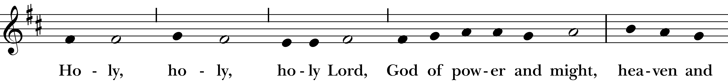
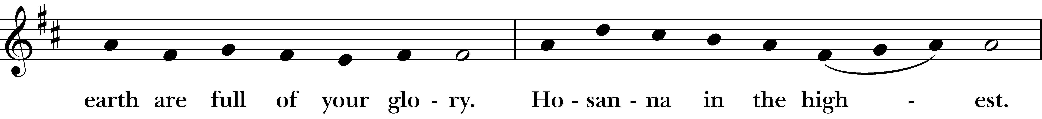
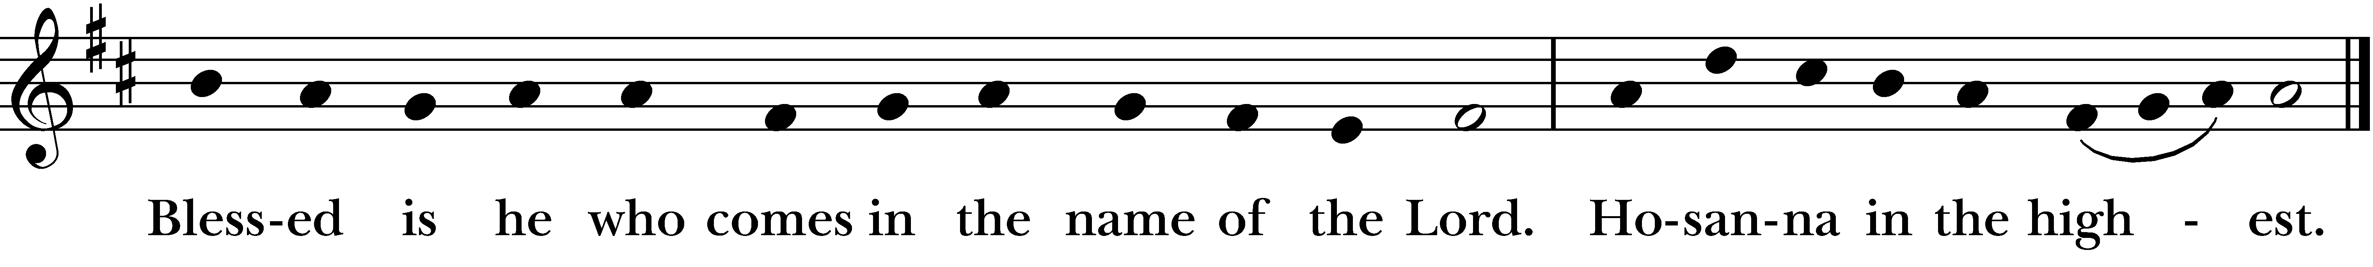
Celebrant: As our Savior Christ has taught us, we now pray:
The Lord’s Prayer
Our Father who art in heaven, hallowed be thy Name,
Thy kingdom come, thy will be done, on earth as it is in heaven.
Give us this day our daily bread. And forgive us our trespasses
as we forgive those who trespass against us.
And lead us not into temptation, but deliver us from evil.
For thine is the kingdom, and the power, and the glory,
for ever and ever. Amen

Breaking of the Bread:
Celebrant: Alleluia. Christ our Passover is sacrificed for us;
People: Therefore, let us keep the feast. Alleluia.

Fraction Anthem: S-154 David Hurd
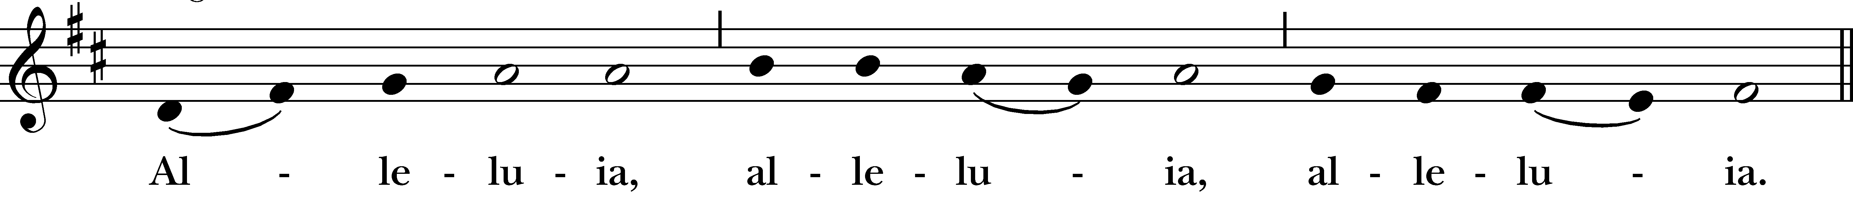
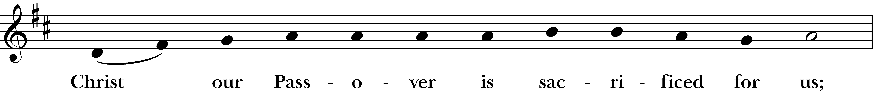
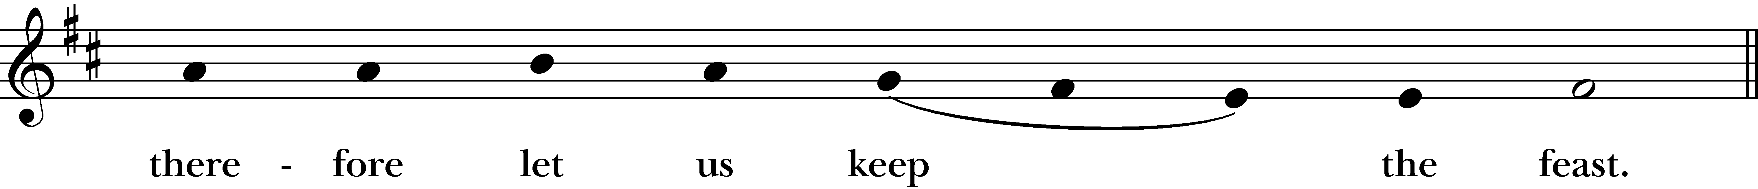
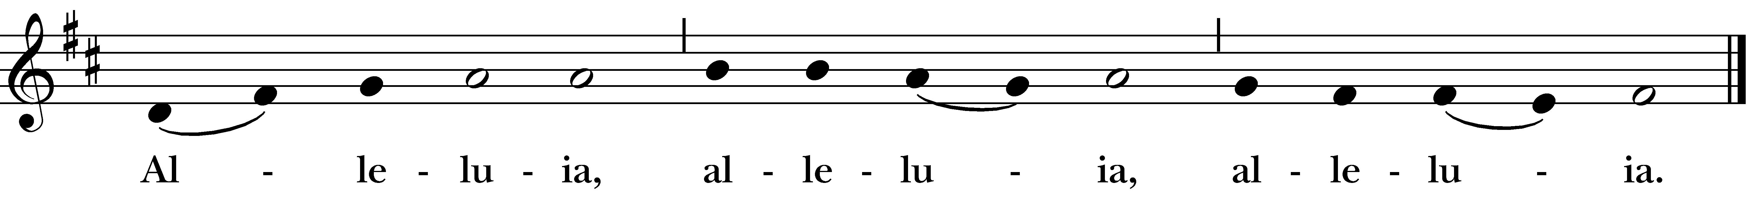

Invitation to Communion
Priest: The Gifts of God for the people of God.

Everyone is welcome at God’s table.
You are invited to come forward and receive communion.
Gluten free wafers are available – please indicate to the priest if you would like one.
Communion Music

Prayer After Communion BCP, p.365
All: Eternal God, heavenly Father, you have graciously accepted us as living members of your Son our Savior Jesus Christ, and you have fed us with spiritual food in the sacrament of his Body and Blood. Send us now into the world in peace, and grant us strength and courage to love and serve you with gladness and singleness of heart; through Christ our Lord. Amen.

Candle Lighting Hymn #79 O, Little Town of Bethlehem

The congregation lights one another’s candles during the hymn
as the chapel lights are dimmed.

Hymn #111 “Silent Night”

- Silent night, holy night, all is calm, all is bright
round yon virgin mother and child.
Holy infant, so tender and mild,
Sleep in heavenly peace. Sleep in heavenly peace.

- Silent night, holy night, shepherds quake
At the sight, glories stream from heaven afar,
Heavenly hosts sing Alleluia! Christ, the Savior, is born!
Christ, the Savior, is born!

- Silent Night, holy night, Son of God,
Love’s pure light radiant beams from thy holy face
With the dawn of redeeming grace,
Jesus, Lord, at thy birth. Jesus, Lord, at thy birth.

Christmas Blessing
Celebrant: May God, who in the Word made flesh joined heaven to earth and earth to heaven, give you his peace and favor. And the blessing of God Almighty, the Father, the Son and the Holy Spirit, be upon you and remain with you for ever. Amen.

Closing Hymn: “Joy to the World!” Hymnal 100
- Joy to the world! The Lord is come; let earth receive her King;
Let every heart prepare him room,
And heaven and nature sing, and heaven and nature sing,
And heaven, and heaven and nature sing.

- Joy to the world! The Savior reigns; let us our songs employ,
While fields and floods, rocks hills and plains,
Repeat the sounding joy, repeat the sounding joy,
Repeat, repeat the sounding joy.

- No more let sins and sorrows grow, nor thorns infest the ground
He comes to make his blessings flow
Far as the curse is found, far as the curse is found
Far as the curse is found.

- He rules the world with truth and grace, and makes the nations prove
The glories of his righteousness,
And wonders of his love, and wonders of his love,
And wonders, wonders of his love.

The Dismissal
Celebrant: Rejoicing in the Messiah’s birth, let us go forth into the world in peace, to love and serve the Lord.
Alleluia, Alleluia!
People: Thanks be to God. Alleluia, Alleluia!

Postlude

Christmas Memorial Giving
Given by |  | In Loving Memory of
Judith | Banks | John Banks
Trisha Beatty | & George Dagon | Petra & Jack Beatty, Mary Ellen Dagon
Carolyn | Bouchard | Frank Sighinolfi
Claire | Bracaglia | Henry Lindert, Henry Jones, Helen Wason
Cynthia | Brinkman | John G. Brinkman, Jr.
Clyde and Georgette | Conrad | All our military away from home at the holidays
Marge | Dill | Michael Dill, Joan Conley
Henry & Joyce | Dombrowski | Henry & Elizabeth Dombrowski, John and Angie Banulski,  Judy, Dave & David Martin
Marcia & Chuck | Eaton | Ethel, Harrison, Harry & John Eaton
 |  | Barbara, Georgia, George & Lee Potterton, Jack & Pam
The | Eells Family | Clarence and Terry Michaud, and Bonnie Eells
Stephen & Victoria | Fisk | Aunt Yolanda Bettancourt, in memorandum for her life (RIP Nov 13 2023)
Marcos Antonio Vidal-Mardones (Victoria's Father),
in Memorandum for his life
The | Forrest Family | Walter Forrest, George W. Clark
Maryann | Hickelton | My St. Peter's Family
Gayle Porter | Kataja | Peter C. Kataja, Merle N. & E. Earl Porter, Kyle P. Buttice
Kathy | Kniep | Jeanne and Robert Wessman, Paul LeBreton; Evangeline and Blanche Kniep

Judy | Knowlton | Douglas A. Knowlton, Thomas Knowlton
Ron | Kolanowsksi &  Art Engler | Mel & Helen Hiltabel, Art & Helen Kolanowski, Lori & Julie Kolanowski, Germain & George Kolanowski, Joseph and Anna Brandis, Thomas and Pearl Walker
Curt & Ellen | Kraemer | Joann Vechinsky
Mary | Latour | Alice Hagenow, Richard J. Hagenow, Richard T. Hagenow
John | Loge | Frances Jean Loge, Beverly Jane Sandefur,  Judith Marion Gray, Stuart Edgar Power
Lynda | Majewski | Paul Louis Arruda
Bob | ManWarren | Lavern and Nita Manwarren
John & Sandy | Marshall | Their parents
The | Mondrach Family | for our beloved family members who have gone before us.
Nelson and Marianne | Moore | Kenneth Moore, Glenn Moore, Maitland Moore
 |  | Martha Moore, Herbert G. Richter, Linda Richter
The | Myers Family | P. Hamilton & Ruth Myers; Tom and Martha Bombaci;  Bob & Bev Winter
Christine | Nosal | Ron Tredor
The | O'Shea Family | Jean & Ray Baldwin, Carbery & Genevieve O'Shea, Genevieve Alexander, Margo Fletcher, Christine Morrison, Sean O'Shea, Juanita & Jack Alden
The | Osmond Family | Cleo & Doris Wandling, John B. & Mildred Osmond, John C. Osmond
John & Susan | Ostrout | Elmer H. Ostrout, Sr., Dorothy R. Ostrout,  William Murray, Shirley Murray, Edward Murray
Barbara | Parkyn | Our Family loved ones; Marge Caton
Steve | Platz | Judy, Ed & Linda Platz
 |  | Henry & Evelyn Dickinson
Chris & Chad | Raasumaa-Boots | Nana, Bachi & Dziadzi
Lianie | Unterzuber | Bob Gorcenski, Dee Urban, Maidey
 |  | Mary Jo Keenan, John Romero
 |  | Debbie Bell, Anastasios Philippou
John | Viklinetz | Helen Joy Viklinetz
Stephanie | Wheeler | Russell H. Wheeler, Jr.
Stephen | Wells | Carol A. Wells

Gifts Given in Honor
Given by |  | In honor of
Cindy | Brinkman | Her grandchildren.
Stephen & Victoria | Fisk | Family and friends: In Thanksgiving/Gratefulness  for their lives
The | Forrest Family | Ryan Clark and service members
Steve | Konopka | Jesus, wishing him a happy birthday
Cathie & Ray | Litwin | In thanksgiving for all our family and friends
Antonella | Woerle | In support of St. Peter’s

Many thanks to the musicians who have contributed to this service with their talents

-

For unto us a Child is Born
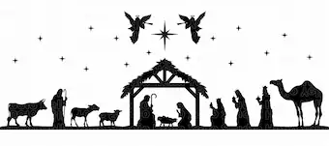

O, Come let us adore him

